Questions are received through the Comptroller’s and MassHealth Help lines regarding the remittance data provided for MassHealth payments. This Job Aid has been developed to assist providers in their reconciliation of MassHealth payments and the data provided from MassHealth.

This Job Aid will show you how to:
- Compare Payment History Information in VendorWeb to the MassHealth Remittance Advice.
- Define the Payment Reference # in terms of what each section of numbers represent on the MassHealth Remittance Advice.
- How to match the payment reference number to various portions of the last page of the MassHealth Remittance Advice.

Background:

There are two distinctly different numbering conventions used for MassHealth remittance payment identifier numbers:

- The current MMIS system-generated payment reference number is 27 character spaces long, including 2 dashes separating the number into three distinct sections. This numbering convention is used to reference payments processed for claims billed from June 1st of 2009 to the current day.

- The previous Legacy MMIS system-generated payment reference number is a 30-digit number, with no dashes incorporated into the number sequence. This numbering convention is used to reference payments processed for claims billed prior to June 1st of 2009.

This job aid will demonstrate the use of both numbering systems, beginning with the current MMIS system used on the most current claims and ending with instructions for the Legacy MMIS system.

Current MMIS Instructions

Step 1 - From the VendorWeb Payment History page.
Payments should always show results as “Group by Payment”
Locate your Payment Reference Number.
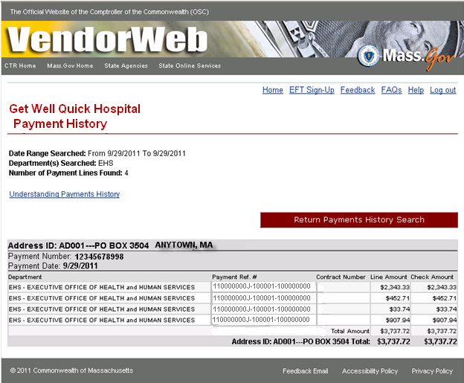

Step 2: From the last page of your MassHealth Remittance Advice.
The screenshot below identifies how the VendorWeb Payment Reference number is identified on the last page of your MassHealth Remittance Advice.

The Payment Reference # displayed on VendorWeb is broken down into three sections as follows:
[110000000J]-[100001]-[100000000]

The first ten digits of the Payment Reference number is your Provider Number located in the top right portion of the page (110000000J)
The next six digits of the Payment Reference number represents the Run Number (100001)
The last nine digits of the Payment Reference number represents the Voucher Number which is located in the lower portion of the page (100000000)

The following are the run and voucher number series for the different types of payments:

Run # Voucher #
Starts Starts
Type of Cycle With With
Claims 100000 100000000
Expenditures (Monday-Thursday) 600000 700000000
Expenditures (Friday) 700000 800000000
Managed Care 200000 500000000
PIP 300000 600000000
EHR 400000 660000000
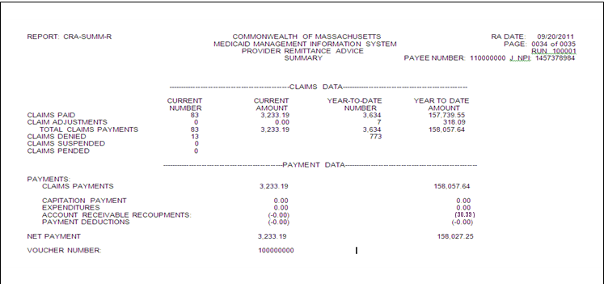
Retro 500000 400000000

Legacy System MMIS Instructions

Step 1 - From the VendorWeb Payment History page.
Payments should always show results as “Group by Payment”
Locate your Payment Reference Number.
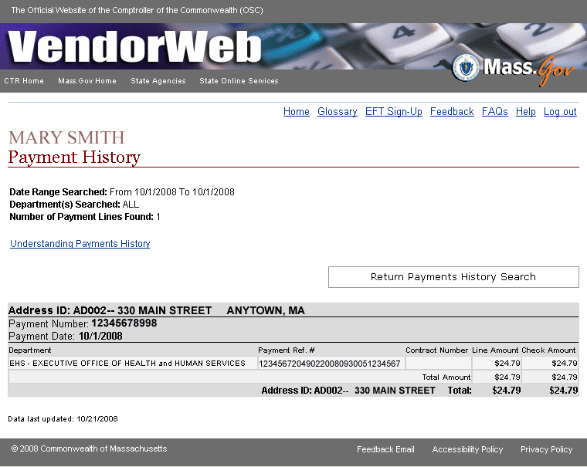

Step 2: From the last page of your MassHealth Remittance Advice.
The screenshot below identifies how the VendorWeb Payment Reference number is identified on the last page of your MassHealth Remittance Advice.

The Payment Reference # displayed on VendorWeb is broken down as follows:
[1234567][2049][02][20080930][05][3123456]

Digits 1-7 of the Payment reference number is your Provider Number located in the top right portion of the page (1234567)
Digits 8-11of the Payment Number represents the run number (2049)
Digits 12-13 of the Payment Reference number represents the invoice type which is located in the top left portion of the page (02)
Digits 14-21 of the Payment reference number represents the actual remit date in the upper right corner next to the run number (20080930)
Note* Digits 22-23 are the provider type number located on the Payment Reference Number in VendorWeb but not located on the MassHealth Remittance Advice (05)
Digits 24-30 represent the Voucher Number located on the left bottom portion of the page (3123456). Note* The first digit displayed on this page is not included in the Payment Reference # displayed on VendorWeb

